1. Consider adding a similar table and graphs for our proposed work. This I have taken from our base paper.

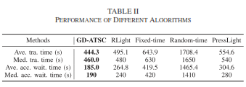

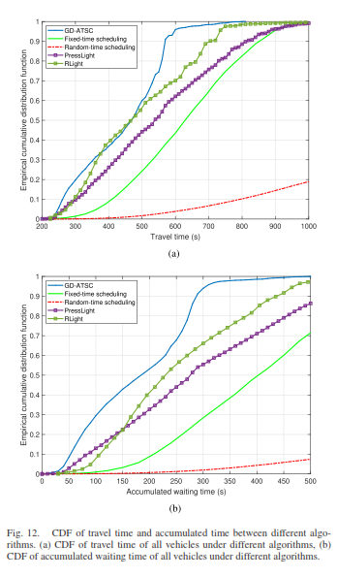

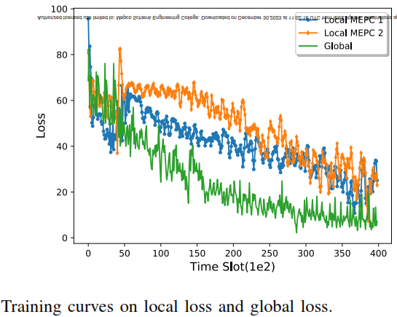

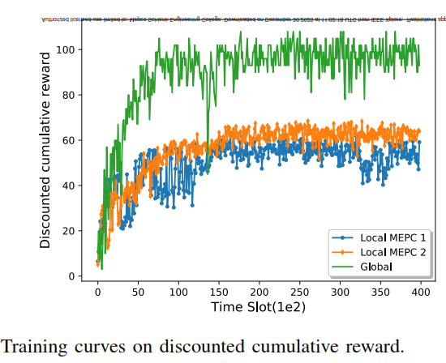 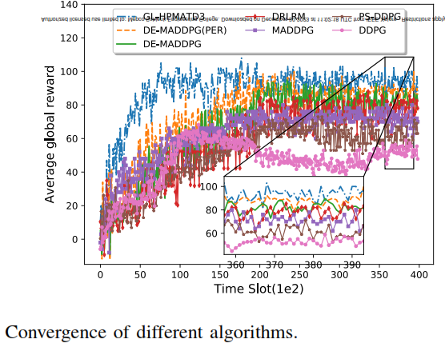 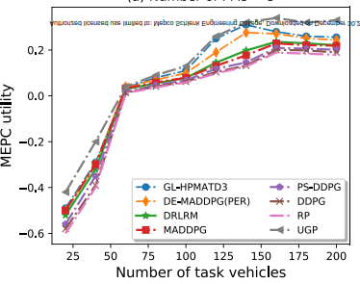

2. The following I have taken from another paper. Based on the possibility, consider adding the following

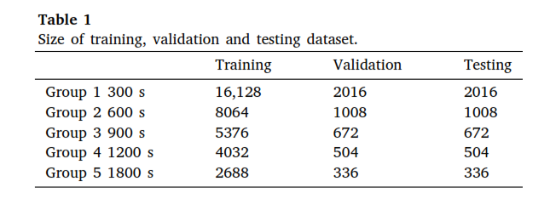

Some thing similar to the following according to our proposed one. We have included the Model Training Configuration

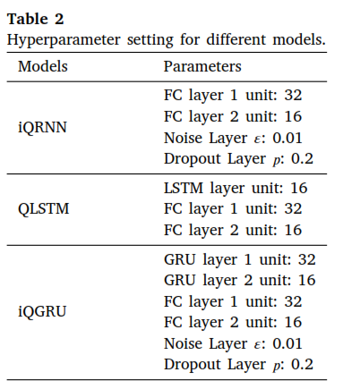

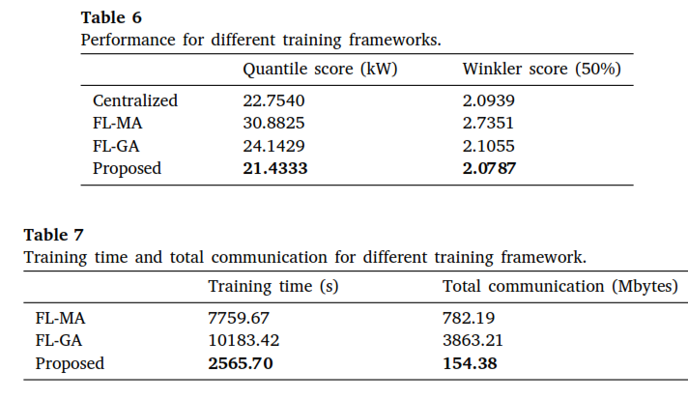

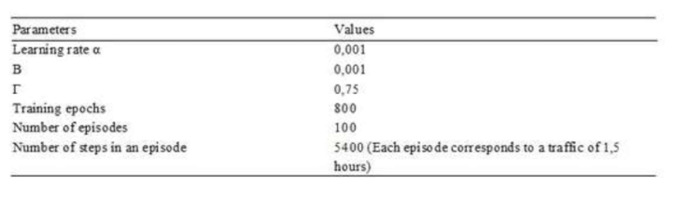

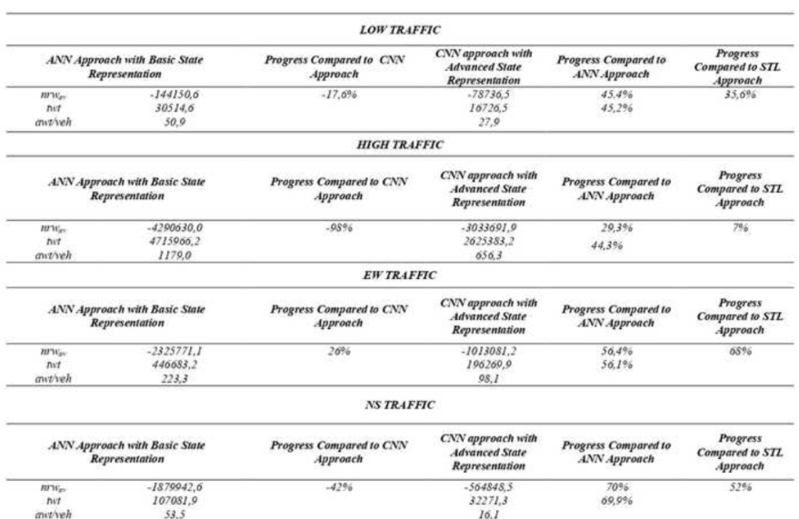

3. A more detailed diagram like one of the following for our proposed work

The following I have taken from other papers.

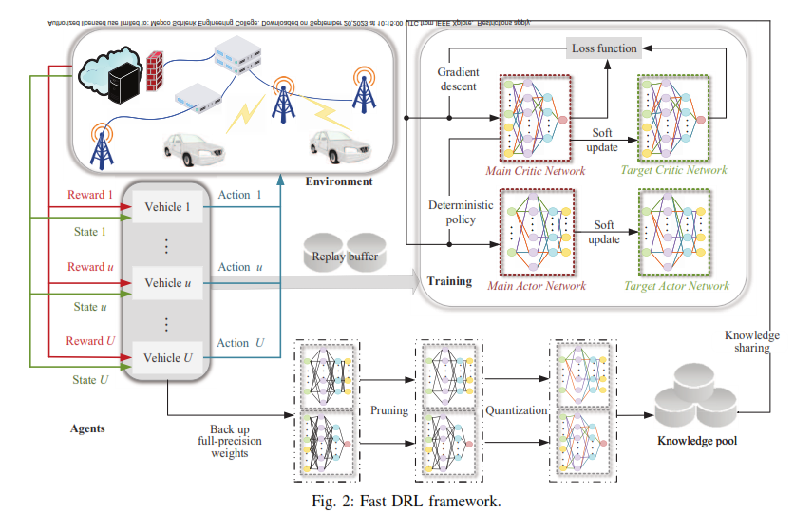

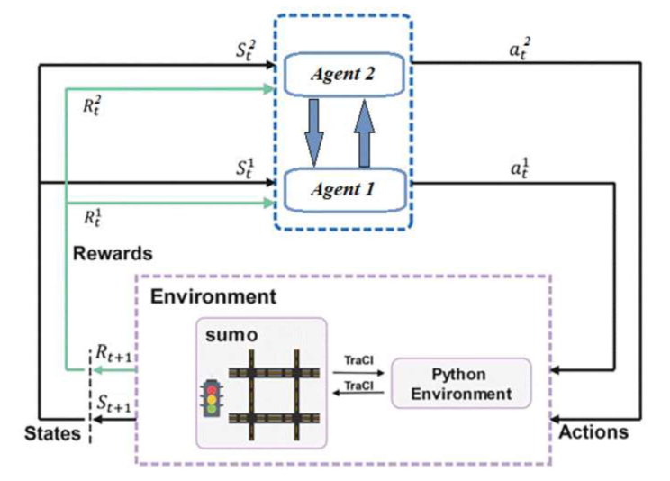

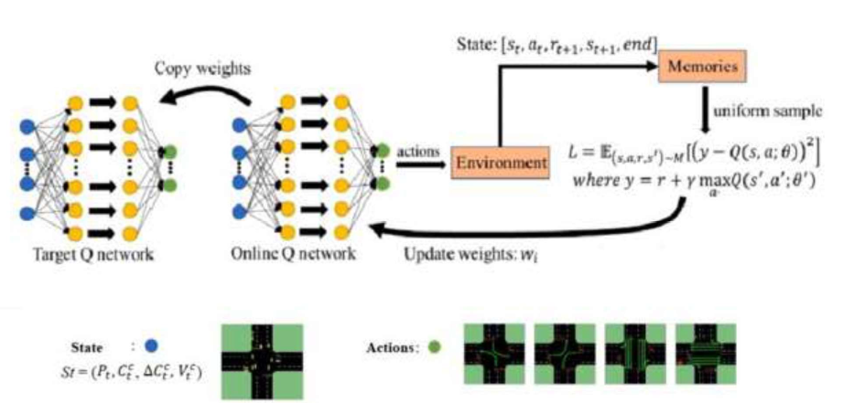

4. Some of the things that can be added from your project report are

Table 3.2. SUMO Software Configuration

|  |  |
| --- | --- |
| **Variable Name** | **Value** |
| net_file | nets/2x2/2x2.net.xml |
| route_file | nets/2x2/2x2.rou.xml |
| out_dir | outputs/trf_wt_8/trf-dqn-hu |
| single_agent | False |
| use_gui | False |
| num_seconds | 3600 |
| yellow_time | 1 |
| min_green | 10 |
| max_green | 40 |
| reward_fn | diff-waiting-time |

1. **STATE VALUES EXTRACTED FROM SUMO:**

Table 5.1 Waiting times that are taken as input by the Transformer based DQN.

|  |  |  |  |  |  |  |  |
| --- | --- | --- | --- | --- | --- | --- | --- |
| **Lane 1** | **Lane 2** | **Lane 3** | **Lane 4** | **Lane 5** | **Lane 6** | **Lane7** | **Lane 8** |
| 212 | 5138 | 0 | 829 | 7259 | 0 | 0 | 1250 |
| 1385 | 7224 | 0 | 2089 | 9779 | 837 | 0 | 1430 |
| 1445 | 7344 | 0 | 2149 | 9899 | 897 | 0 | 1542 |
| 1225 | 6901 | 0 | 2024 | 9010 | 720 | 0 | 1222 |
| 1134 | 5680 | 0 | 1980 | 8020 | 602 | 0 | 1010 |